**Sprint-2**

|  |  |
| --- | --- |
| **Date** | **6 NOVEMBER 2022** |
| **Team Id** | **PNT2022TMID13490** |
| **Project Name** | **Gas Leakage Monitoring and Alerting System** |

**To Detect The Gas Leakage:**

**int val = A0; void setup()**

**{**

**pinMode (9,OUTPUT); pinMode (A0,INPUT);**

**Serial.begin(9600);**

**}**

**void loop()**

**{**

**val = analogRead (A0); if (val <500 )**

**{digitalWrite (9, LOW);}**

**else**

**{digitalWrite(9, HIGH);}**

**}**

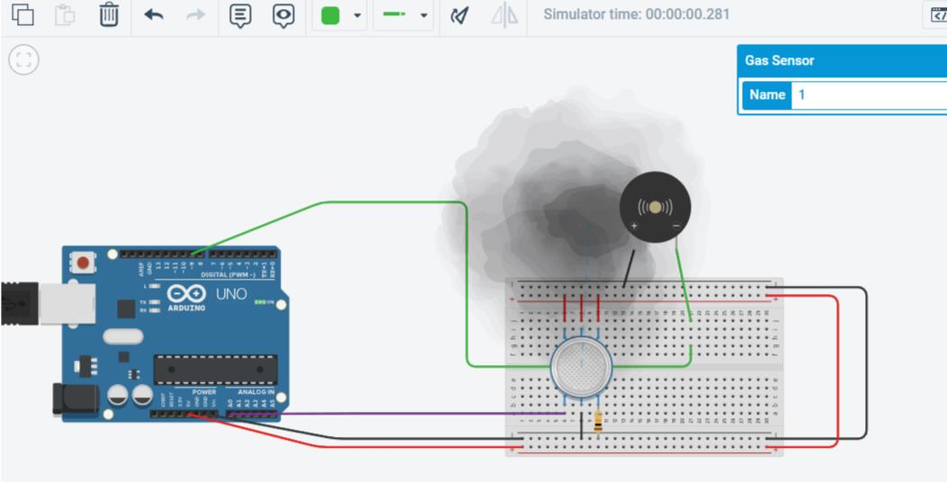

The Owner can take necessary steps by deploying Gas detectors in their surroundings.